WebEOC User Guide
General User Training

  - May 2018
  - Version 1

Tallahassee-Leon County GIS
301 S. Monroe Street P-3
Tallahassee, FL 32301

Document Revisions

Date | Version Number | Document Changes
5.17.2018 | 1 | Initial Draft

Table of Contents
1 Introduction 1
1.1 Scope and Purpose 1
1.2 Purpose 1
1.3 Audience 1
1.4 WebEOC Board Definitions 1
1.5 Contact 1
2 Getting Started 2
2.1 Logging On 2
2.2 WebEOC Home Page 6
2.3 Sign In / Out 6
3 Menus 8
3.1 Leon – Useful Links 8
3.1.1 Leon Useful Links - Link Definitions 9
3.2 Power Outages 10
3.2.1 Power Outages - Link Definitions 10
4 Leon County Map 11
5 Event Intake Board 12
5.1 Inbound Activity Log Board 12
5.1.1 Input an Event: Call from a Citizen 12
6 Resource Request Board 17
6.1.1 Reviewing Resource Requests: Assigning a Request (requires controller permissions) 17
6.1.2 Assignments: The users view 19
7 Frequently Asked Questions 24
What is my username? 24
What if I forgot my password? 24
What if my account is locked? 24
What if a board I need is not on my control panel? 24
8 Board Definitions 24
9 Resource Request Status Definitions 25
10 Terms 27

Introduction

Scope and Purpose
WebEOC has been adopted as the County’s incident management software tool. WebEOC has the ability to allow the user to generate, post, transmit and share information in real-time with other WebEOC users. It is imperative, that all Leon County Emergency Operations Center (EOC) representatives and partner agencies utilize this tool during an event, or incident to ensure that preparedness; response and recovery actions; resource requests; and demobilization are documented and tracked during the incident, or event. This tool is designed to help the EOC capture vital information that will be used to respond to the needs of County residents as well as create Incident Action Plans (IAPs), Situation Reports (SitReps), Press Releases, After Action Reports (AARs), etc. Information entered into the system should be considered as recorded legal documentation of actions taken.
The WebEOC User Manual is a living document. This is due to WebEOC boards being developed or revised to meet up to date user needs.

Purpose
The purpose of this document is to provide step-by-step instructions on using WebEOC as an end user as well as to address the overall conceptual management of an emergency situation in Leon County. This document will also outline applicable operational policies for the implementation of WebEOC in the Leon County Emergency Operations Center (EOC).

Audience
This document is for WebEOC users supporting the Leon County’s instance of WebEOC, which includes the EOC Staff, Leon County employees, municipal response personnel, and other authorized partner organizations and disaster response stakeholders.

WebEOC Board Definitions
WebEOC is comprised of a series of “boards” that have been tailored to each position in the Emergency Operations Center (EOC). WebEOC Board Definitions will help users understand the purpose of these boards and identify the positions that are responsible for inputting and updating their information.

Contact
You can contact the Region 2 Administration Group here: http://webeocregion2fl.org/techEmail.asp

Getting Started

Logging On
Step | Action
1 | Open your web browser.  - *Note: WebEOC will not work with IE9. It is suggested that you use IE 11, Google Chrome or Firefox as your web browser.
2 | Type http://webeocregion2fl.org into the address bar and then hit enter. This will take you to the WebEOC mini website. Here you will find how to log into WebEOC, contact and weather information that will assist you in your duties.  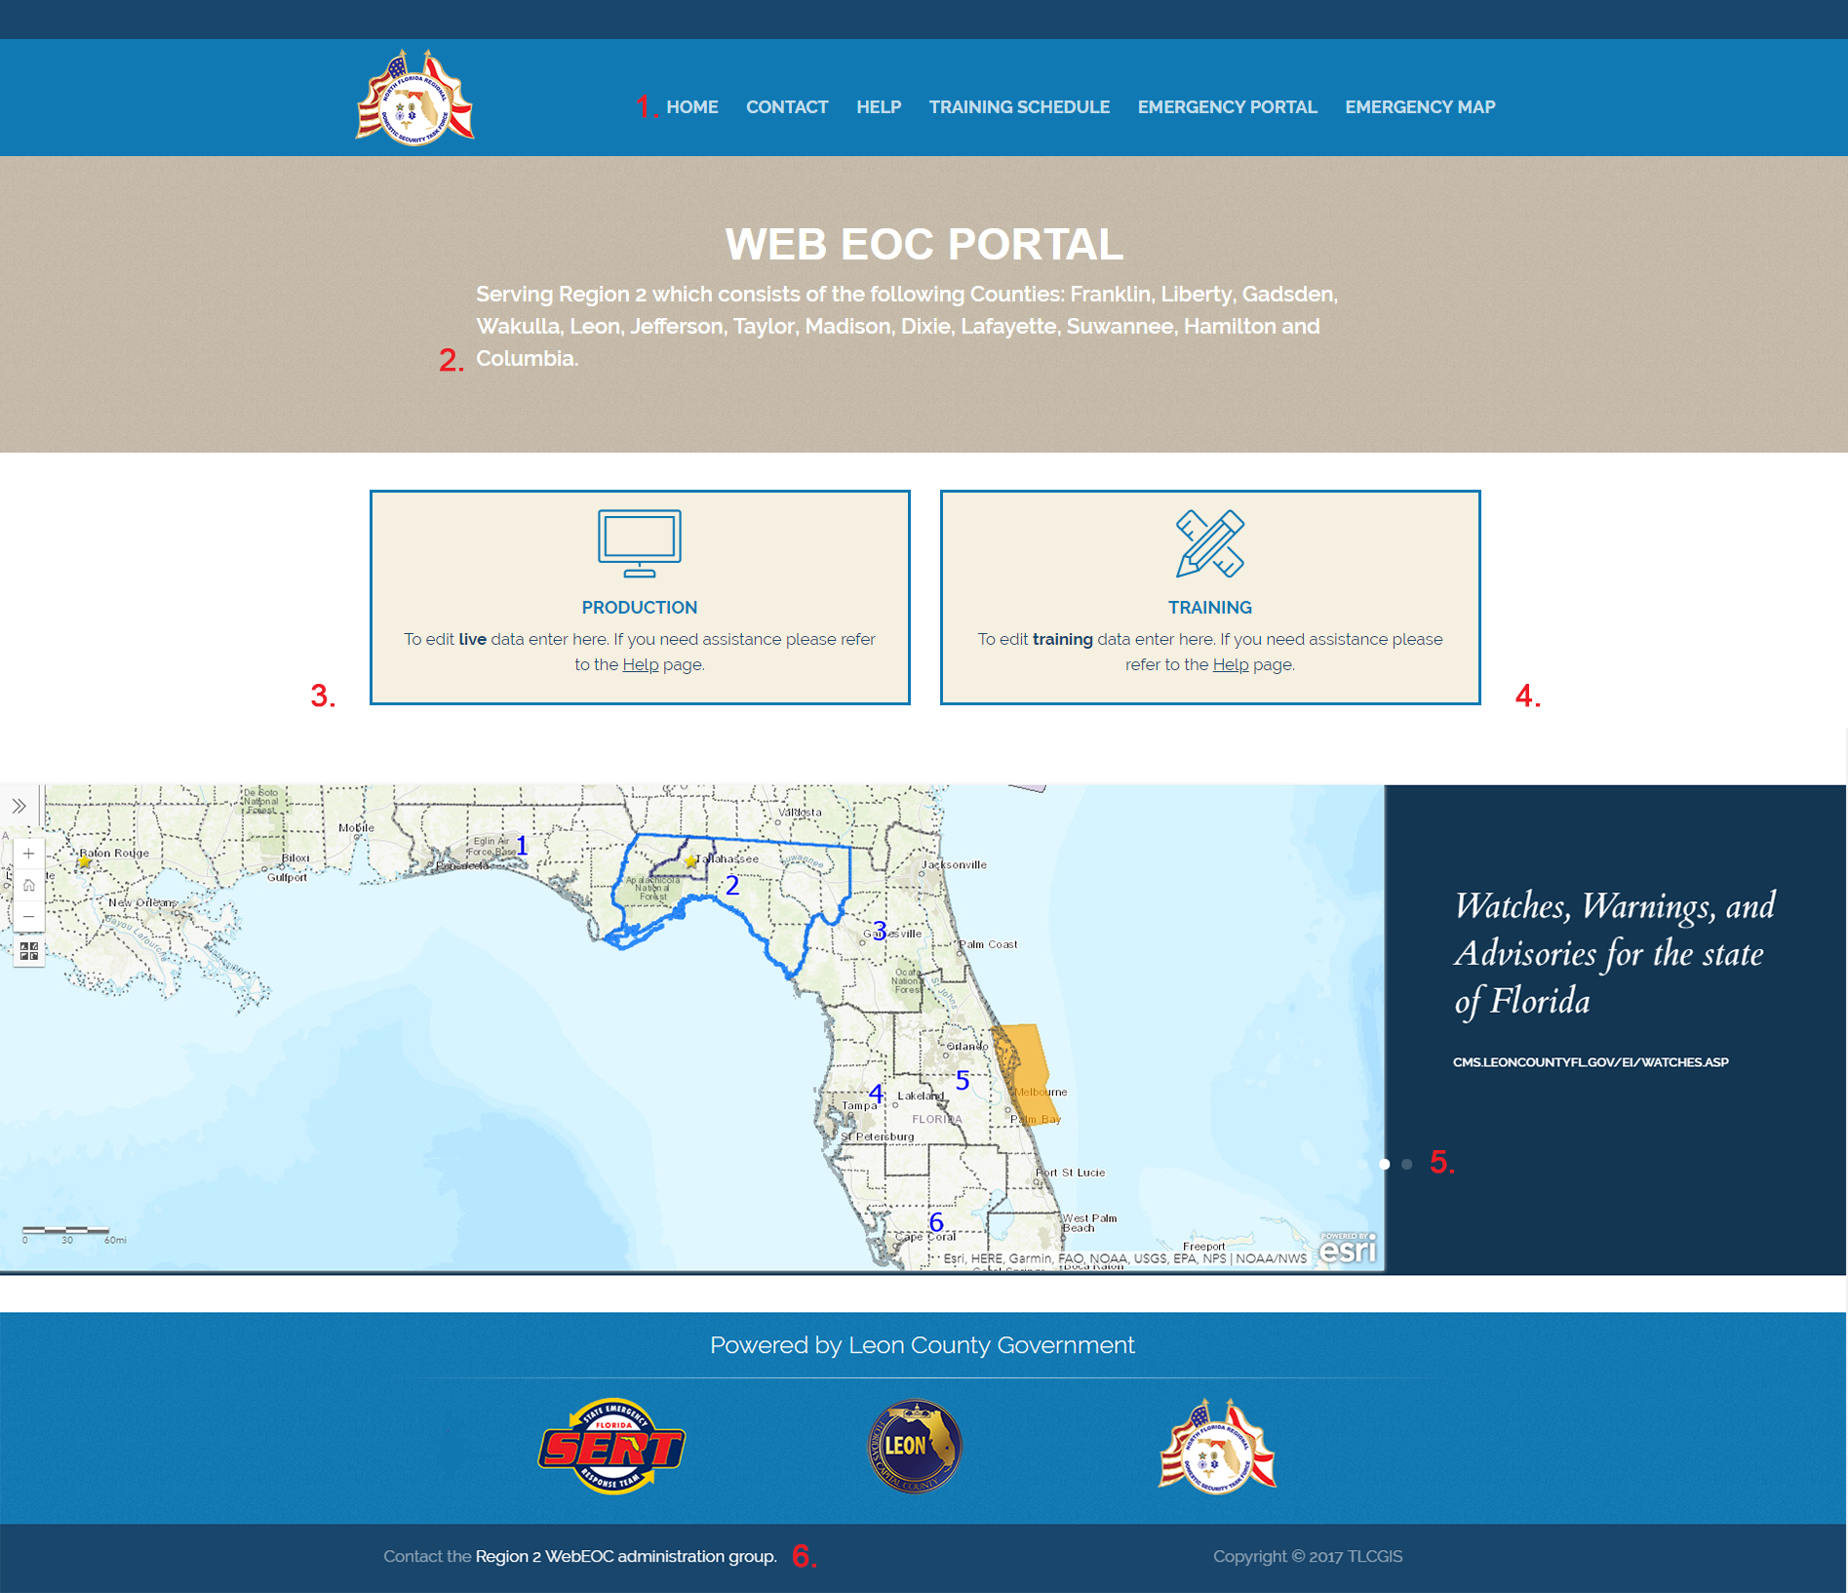  - Navigation:  - Contact: The Contact link will bring you to a County Contact map. Click on the County in question and you will receive the Emergency Directors contact information. This information is also available in a report format.  - Help: Here you will find instructions on how to create a WebEOC account, retrieve a forgotten password and request access to a board.  - Training Schedule: The WebEOC training reservation system.  - Emergency Portal: The Leon County Emergency Information Portal is maintained by the Community and Media Relations Department. This website will have live information on relevant information i.e., weather maps, road closures, school closures and shelters.  - Emergency Map: A GIS mapping application: Land Information – Emergency Management Here you will not only find information on FEMA flood zones, Evacuation Zones, and Roadway Obstructions and0 33 other vital categories.  - Region 2: Use the County list to visit their respective home pages.  - Production Button: Use the Production button to enter the system if you are at a LIVE event.  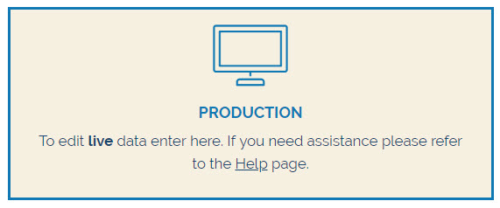  - Training Button: Use the Training button to enter the system if you are at a training event.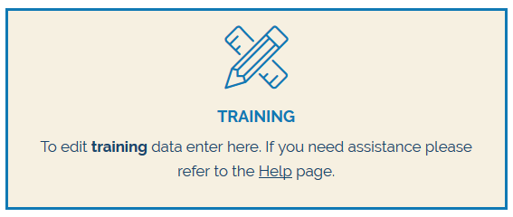  - Weather Maps: The Weather Maps Section scrolls through 3 different mapping applications:  - State of Florida Region Two Contacts  - Watches, Warnings and Advisories for the State of Florida  - Active Tropical Storm Map  - Contact the WebEOC Administration Group: Send a group email to the administrators of the application.
3 | To begin press either the Training or Production button  Result: The button will bring you to the Leon County WebEOC terms and Conditions page.
4 | After reading the terms and conditions click Accept  Result: You will be brought to the WebEOC Login Page.
5 | Type the username and password assigned to you when you registered for a WebEOC Account. Then click Log In  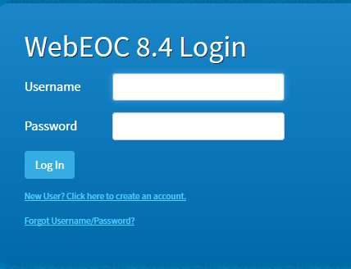  Result: You will be asked to select your Position and Incident  - *Note: After 4 failed log in attempts your account will be locked. If you cannot remember your credentials please use the Forgot Username/Password link and the information will be emailed to you. Visit the Help page for more information: http://webeocregion2fl.org/help.asp
5 | Select your position and incident from the drop down lists.  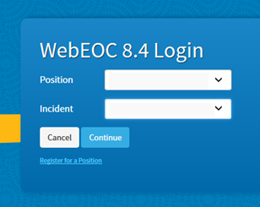  Result: You will be brought to the additional information page.
6 | Fill out your Name, Location, Phone Number and Email address then click Continue  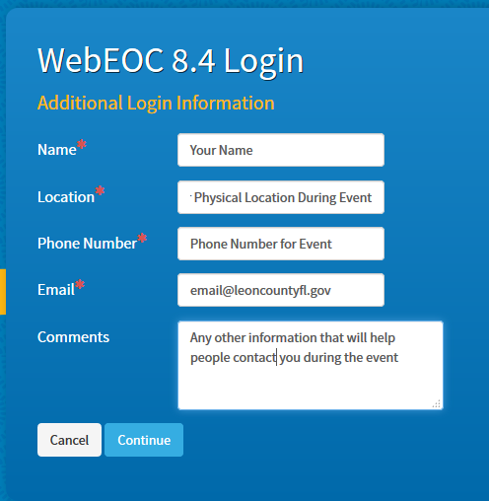  Name: Enter your first & last name  Location: Enter the location in which you are located during the disaster. Examples include: EOC, PSC, Leon County Courthouse, Special Needs Shelter, etc.  Phone Number: Enter a phone number where you can be reached during the disaster, such as the EOC Unit seat you are in or a cell phone.  Email: Enter your work email address.  Result: You will be brought to the WebEOC Home Page.

WebEOC Home Page
Once you log into WebEOC, you will be brought to the WebEOC Homepage. Below is an example of what your homepage may look like when you log in.
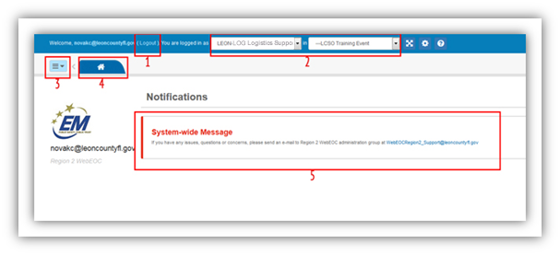
- Click here to logout of WebEOC
- This displays what position and incident that you are logged in as. From the drop down menu, you can either change your position or the incident.
- Click this button to access the Control Panel.
- WebEOC works with tabs. This tab will bring you to the homepage. Once you begin to open boards, more tabs will open to the right of the homepage tab.

Sign In / Out
Once logged in to the system it is important for all staff to “sign-in” to the incident through the Sign In / Out Board.
Step | Action
1 | Access your control panel
2 | Click on the board labeled Sign In/Out (highlighted below)  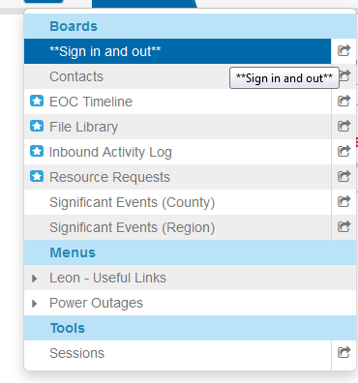
3 | To sign in click the green Sign In button in the upper right corner.  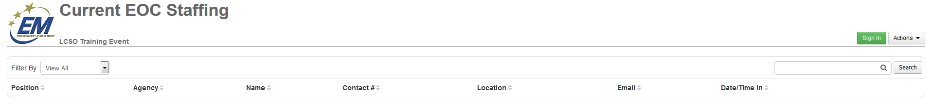
4 | The fields should be pre-populated. If everything is correct click save in the lower right side of the screen.  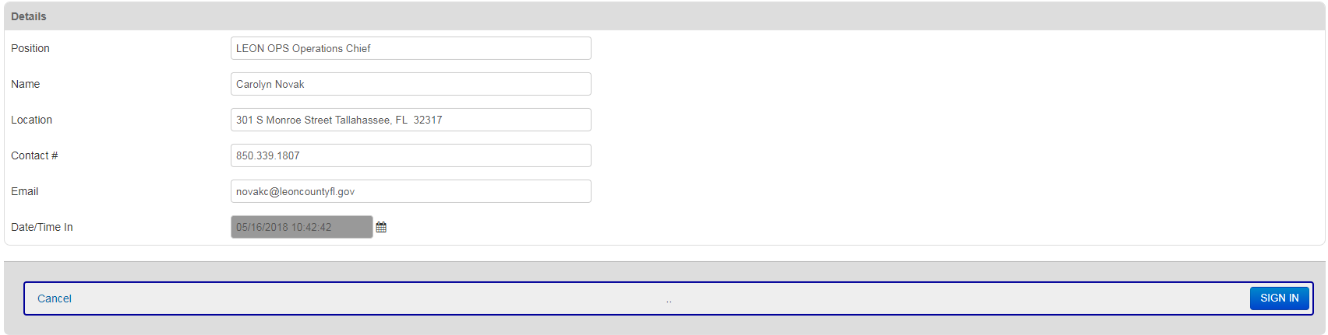

Menus
The information in the menus section has been provided to assist you in working with the public.

Leon – Useful Links
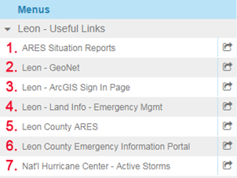

Leon Useful Links - Link Definitions
Link | Action
- ARES Situation Reports | Data collected by the National Association for Amateur Radio
- Leon GeoNet | The Intranet site for the Tallahassee-Leon County GIS Department. The site hosts multiple applications to assist you with questions raised by the citizens. A visit the map gallery http://tlcgeonet.gis.local/portfolio.asp will allow you to view many useful mapping applications to assist you and the citizens.
- Leon – ArcGIS Sign In Page | Users with an ArcGIS online account can use this shortcut to their data.
- Leon Land Info – Emergency Management | A GIS mapping application: Land Information – Emergency Management Here you will not only find information on FEMA flood zones, Evacuation Zones, and Roadway Obstructions and 33 other vital categories.
- Leon County ARES | During a disaster such as a hurricane, flood, forest fire, tornado, or other emergency, traditional communications methods are often unavailable. Telephone networks (including mobile phones), internet backbones, and traditional radio systems are often damaged, and those systems that remain are often overloaded with extremely heavy traffic. It is during such times that amateur ("ham") radio has proven itself repeatedly to be a reliable and invaluable means of helping communities and emergency responders communicate and coordinate relief efforts so that those who need help can receive it.  ARES, the Amateur Radio Emergency Service, is a nationwide volunteer-based group of amateur radio operators who regularly train and drill to provide emergency communications for the community during a disaster or other major emergency. ARES operators are licensed to use a vast array of equipment, frequency spectrum ("air wave space") and transmission methods that enable them to pass message traffic and digital files to local, regional, and international destinations when traditional communications systems have failed.  ARES operators can deploy with their own high-end equipment, though ARES also has pre-stationed equipment at strategic locations (hospitals, police, fire, etc.) throughout the United States to further support the various agencies served.
- Leon County Emergency Information Portal | The Leon County Emergency Information Portal is maintained by the Community and Media Relations Department. This website will have live information on relevant information i.e., weather maps, road closures, school closures and shelters.
- National Hurricane Center Active Storms | Visit this link to view tropical cyclone activity in the Atlantic Basin.

Power Outages
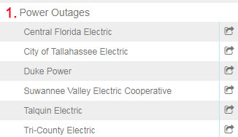

Power Outages - Link Definitions
Link | Action
- Power Outages | This section expands to show links that will take you directly to the “outage” maps.

Leon County Map

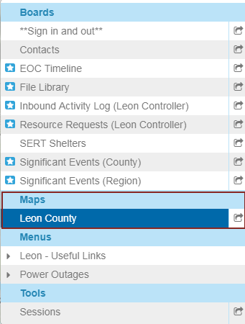
The Leon County Map displays in real time the information from the Inbound Activity Log
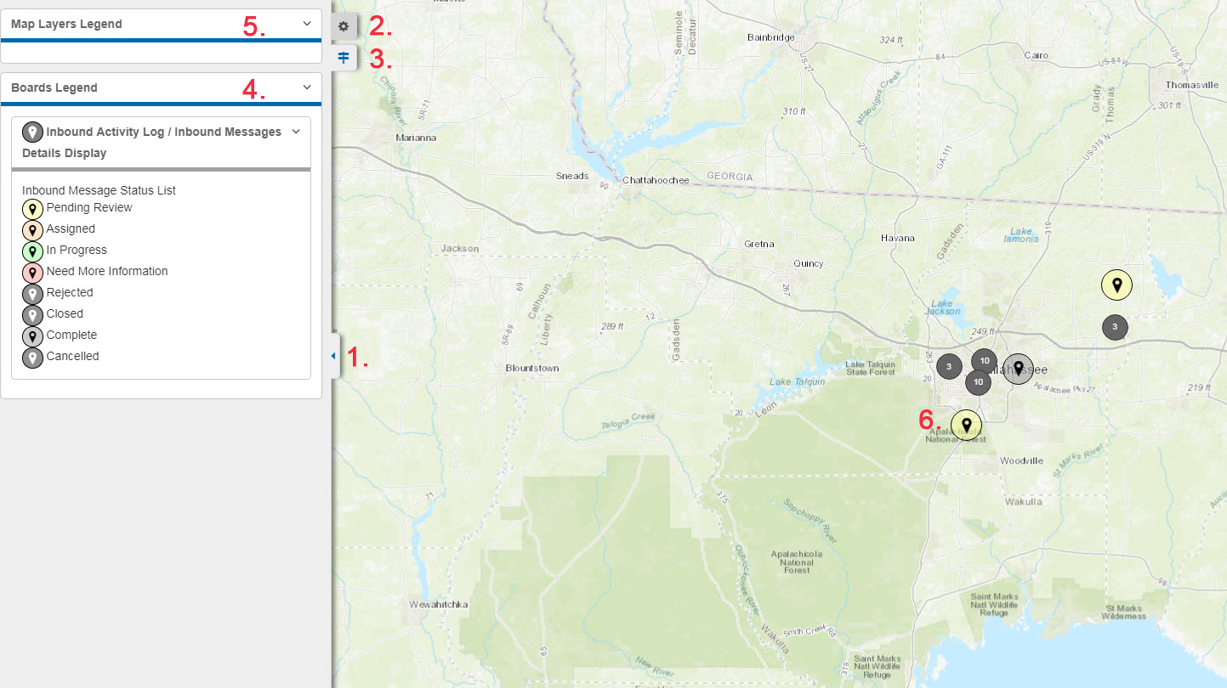
- Side Panel Expand and Contract
- View and Set Settings
- View Legend
- Boards Legend: defines map points
- Maps Layers Legend: allows the user to add or delete layers from their individual map view.
- Map points: display calls from the Inbound Activity Log. Please note if there are multiple addresses in a close distance the points will cluster. You will need to zoom in for a point by point view.

Event Intake Board

Inbound Activity Log Board
The Call Takers are going through the following process. This replaces the paper process used in past events. In our example we will review a call from a citizen.

Input an Event: Call from a Citizen
Step | Action
1 | The control panel is accessed
2 | Inbound Activity Log (highlighted below) is chosen.  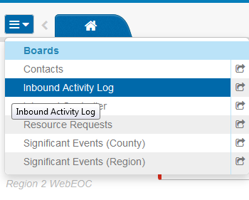
3 | Click on the green New Record button in the upper right corner of the screen.  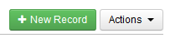
4 | The Source of the information must be chosen. They are presented with different questions depending on the source of the call. For this example citizen is chosen. 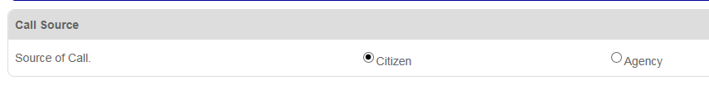  Result: 7 informational sections are then presented to fill out.
5 | Identifying Source  This section is for the caller’s personal information.  Please note: the Social Media information is not a requirement. 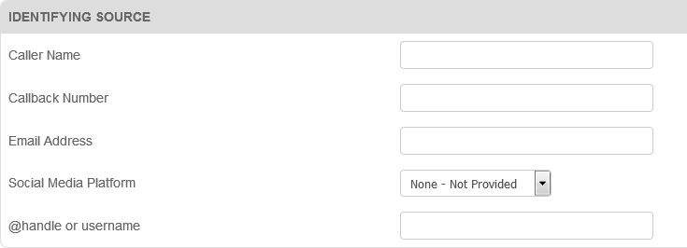
6 | Address of Event  It is asked that as much information as possible is input. When a physical address is not an option cross streets or, to the best of their ability, the area in question is input.  Example : 1809 Bridgemont Trail, Tallahassee, Florida can be found via the address locator.  Once the address is input in the proper format i.e., 1809 Bridgemont Trail, Tallahassee, Florida press the Map link.  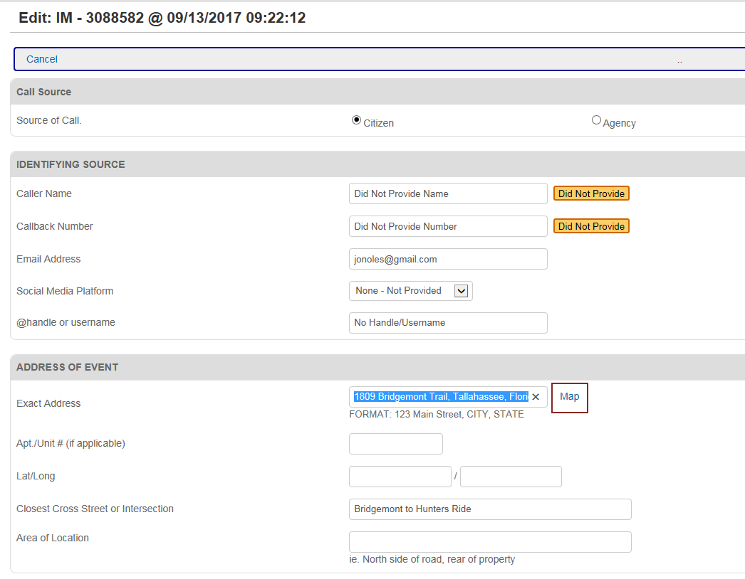  This will launch the mapping feature. 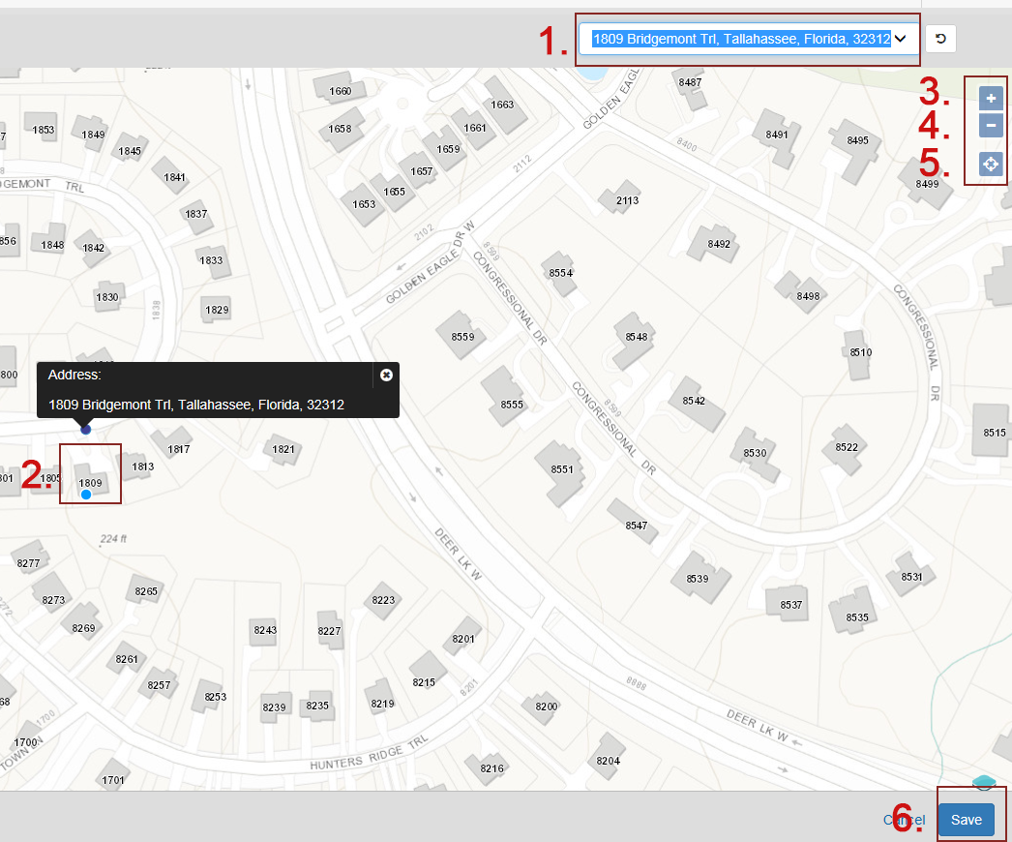  - Click here to view other address possibilities.  - The address point will display on the property. The point can be moved by clicking anywhere on the map.  - Zoom in  - Zoom out  - Home in to your location.  - Save the location.  Once saved you will see a checkmark circled in green verifying that the location was correctly recorded  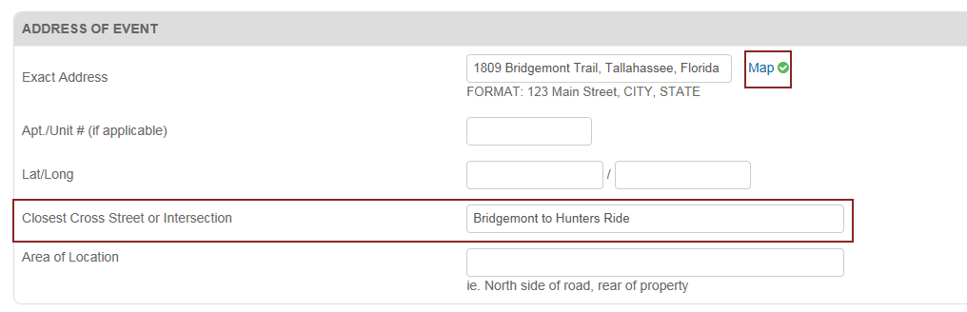  *Note: If you have more information i.e. north side of the house, closest cross street etc. you can input that in the Area of Location field.
7 | Type of Event  This section collects data regarding the reason(s) for the call. There can be multiple reasons. Each event checkbox will create another set of questions for more accurate assessment reporting. In the following example we will review Tree Down:  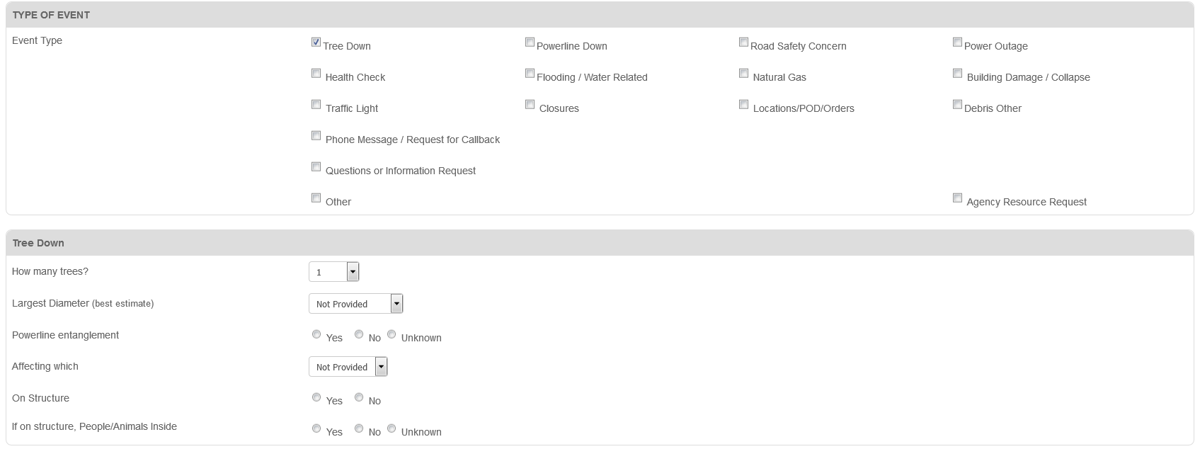  Once the Tree Down Box is checked the Tree Down Area is displayed where more information can be entered.
8 | General Notes and Comments  This section allows the call taker to add important information re the incident. This serves as a running log for reporting purposes.  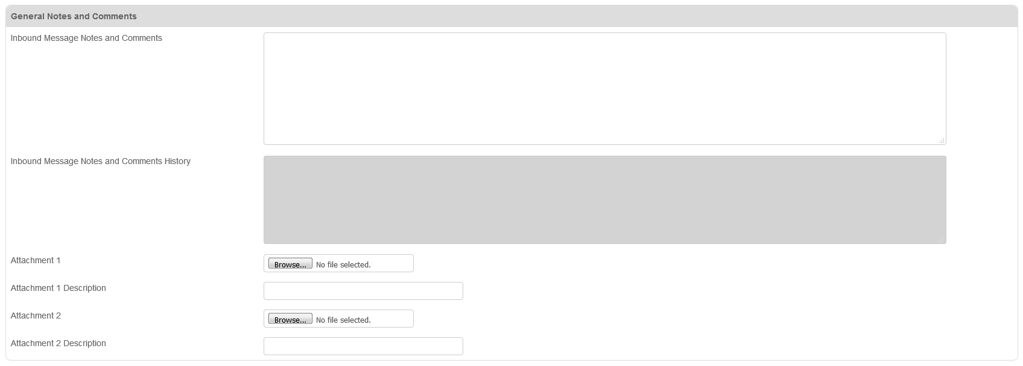
9 | Information Routing  If the event needs to be escalated to expedite resources there are options to  Post to County Significant Events  Post to Regional Significant Events  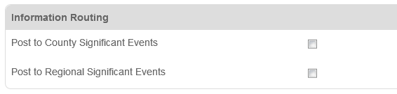  A Significant Event can be as follows:  - The entry is informational in nature.  - The entry affects positions other than the originating position.  - The information in the entry must be confirmed from a reliable source.
10 | Status & Assignment Details  This section is used by the Operations Chief to review the information and then allocate a resource. Please note the Tracking Number is automatically populated.  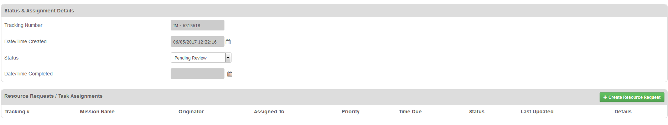
11 | - Save  If you took the call and input the data Save your information by clicking the blue Save button in the lower right side of the screen.

Resource Request Board

Once the call taker submits the information it is available for the Operation Chief to review. The request is displayed in the Inbound Activity log with an Event Status of Pending Review.

Reviewing Resource Requests: Assigning a Request (requires controller permissions)
Step | Action
1 | Access your control panel
2 | Click on the board labeled Inbound Activity Log (highlighted below)  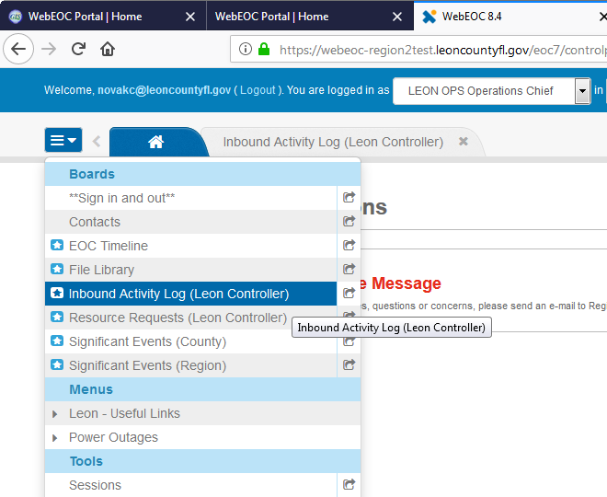
3 | Our example Phone Message / Request for Callback  Questions or Information Request is displayed on the Inbound Activity Log with and IM tracking number of IM-6348176 with and Event Status of Pending Review  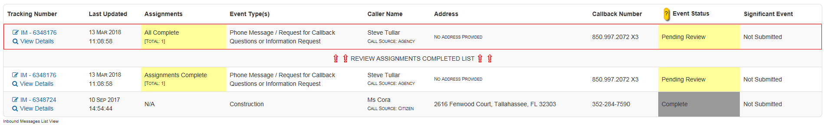
4 | Clicking on View Details option opens a view screen that allows the Operations Chief to Print, Copy or Edit the information.  There are two opportunities to create the resource request. One is by clicking the IM number of the Event and the other is via the View Details screen. Since we are in the View Details screen for this example we will use View Details (the process is the same).
5 | Clicking the Edit button in the upper right corner of the screen displays the information not only in and editable fashion but allows the Operations Chief to Create the Resource Request.  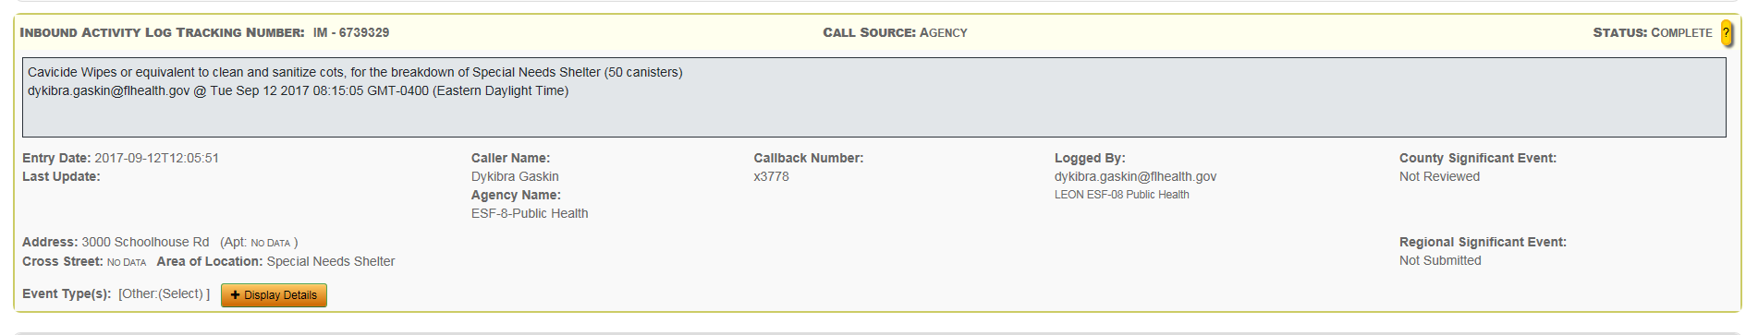
6 | After the Operations Chief reviews the request this could be assigned to Logistics Staff by clicking the Create Resource Request button and adding a Priority and Assignment in Assignment Details.  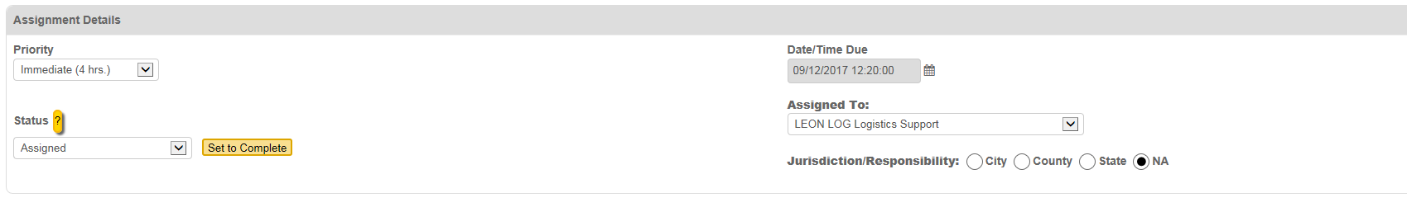

Assignments: The users view
Step | Action
1 | Access your control panel
2 | Click on the board labeled Resource Requests (highlighted below)  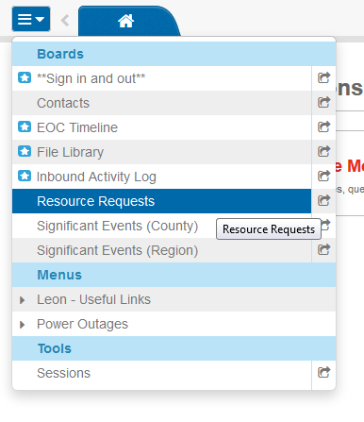
3 | Filters  There are 2 filters available with this board  Status: The status of the event  My Items: Events you assigned or events the user created. 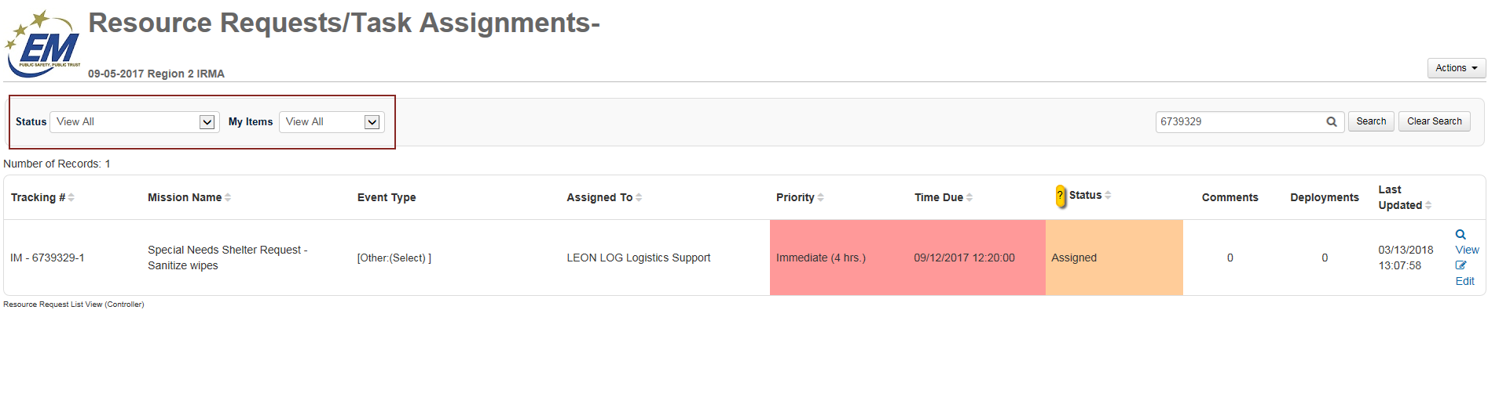
4 | Search  You are able to use the search tool to find an event by Tracking Number,  Mission Name, Status, or the position it was Assigned To.
5 | Mission Status  As a mission is being worked on, the status of the mission will change. Choose the appropriate Status from the drop-down. This will be determined by your Department’s business process.  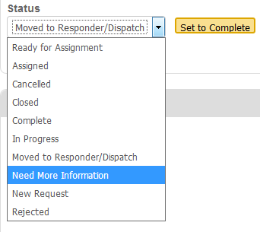  A definition of common Status are listed below:  Assigned: When a mission is assigned to a position the status will be Assigned. From the assigned status a mission should either move to In Progress or Need More Information.  In Progress: When the position assigned the mission begins to work on the mission, they should change the status to In Progress so that all the parties involved know that the need is being addressed.  Need More Information: If the position assigned the mission does not have all of the information necessary to complete the mission, they have the option to change the status to Need More Information so that the mission creator can add the information needed. If you change the mission to this status follow up with the mission originator via a phone call.  Rejected: When the decision is made that a mission will not be worked on it will be Rejected.  Complete: When the individuals assigned the mission complete their task and the need has been met they will change the status to Complete.  NOTE: Each time the status of a mission is changed the individual should also add a comment.
6 | Deployments  When an event involves a resource request, you will be able to add a Deployment to the event. This feature is used to track resources during an incident.  Once the green Add Deployment button has been chosen you will be presented with 4 fields:  Deployment No: This is a unique number to identify the resource. This will be pre-populated.  Resource: The type of resource being deployed. Select from the drop-down.  Quantity: How many are being requested.  Remarks: Additional Comments.  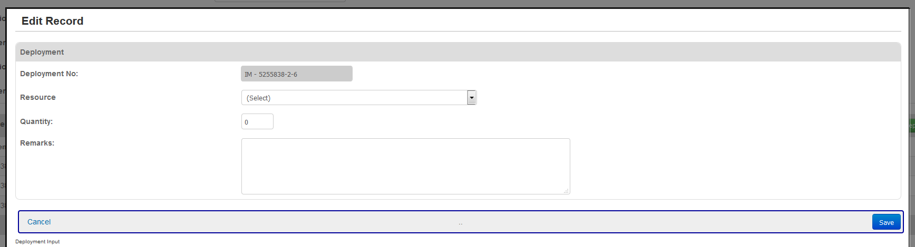  Click the blue Save button in the right corner to complete inputting the deployment request.  Deployments will be listed in the Deployment column and can be viewed via the View or Edit screens.  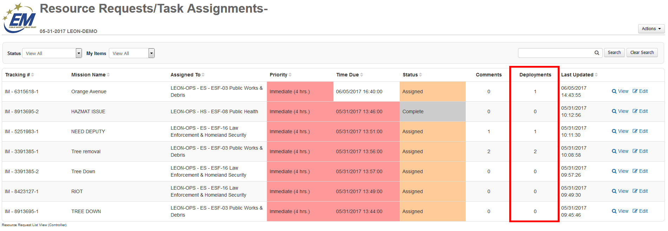
7 | Request a Resource  If upon review it is determined that a resource is needed check the Requesting a Resource box  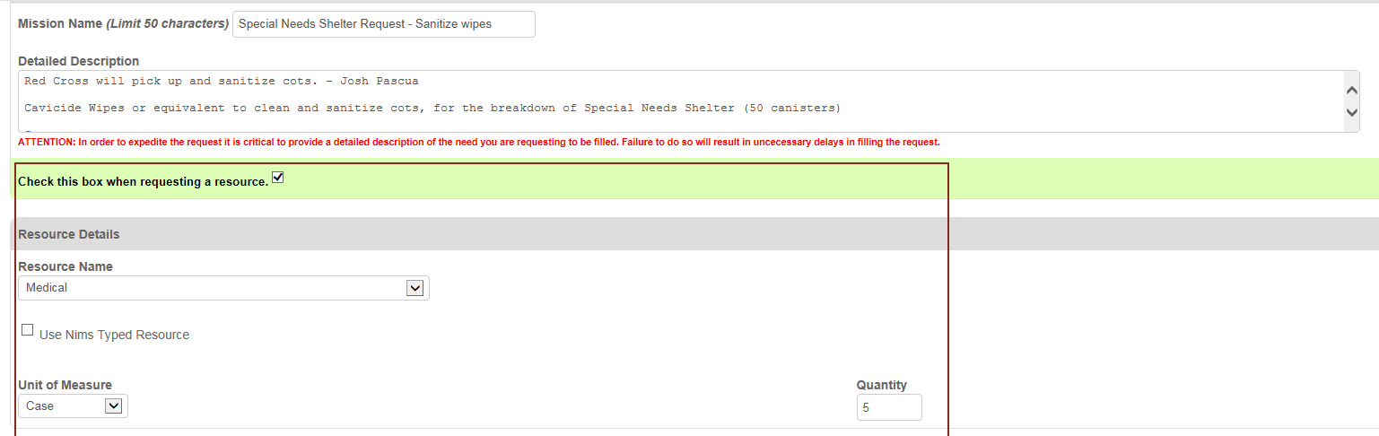  This will allow you to add Resource Details and Coordinating Instructions.
8 | Comments  At the bottom of the Edit page you can add additional comments to the event. This can assist others that are working on the event. Click the green Add Comment button to add a new comment.  Your position, name, phone and the date and time will be pre populated. Insert your comment and click the blue Save button in the bottom right corner of the screen.  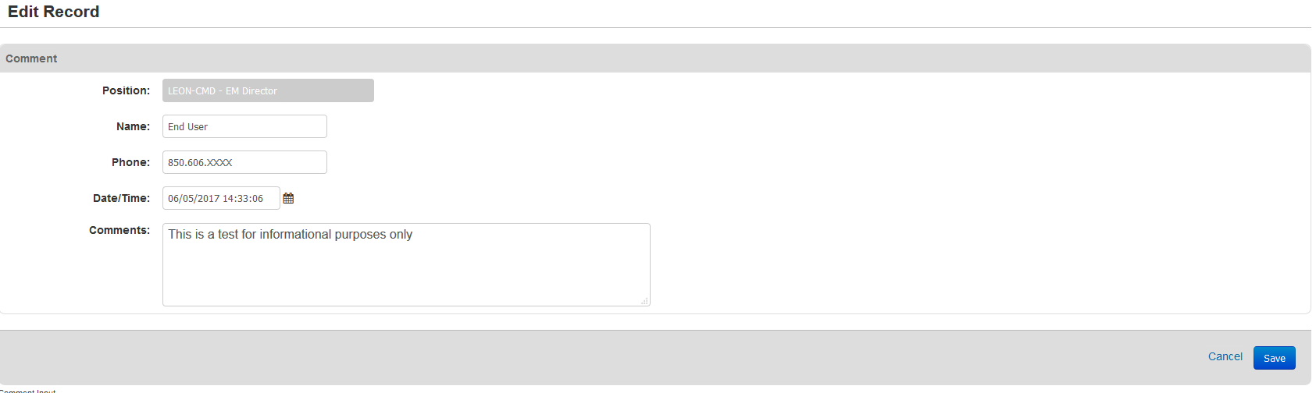

Frequently Asked Questions

What is my username?
Your username is your email address.

What if I forgot my password?
If you forget your password go to the WebEOC homepage and use the Forgot Username Password link.
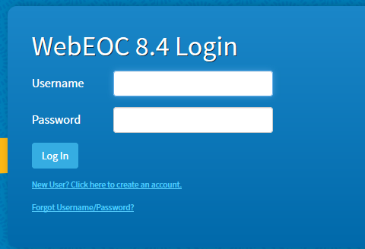

What if my account is locked?
If your account is locked, you will need to send an email to: http://www.webeocregion2fl.org/techEmail.asp to have your account unlocked by an administrator.

What if a board I need is not on my control panel?
If you do not see a board you need on your control panel, it is most likely because the position you are using does not have the appropriate permissions for that board.

Board Definitions
Name of Board | Purpose | Who Can Input Information | Actions Required
EOC Timeline | View timeline of required actions by EOC personnel. | Situation Unit | Update information as the situations change.
File Library | Contains documents utilized as reference for EOC management. | All | Documents need to be updated to the most current version.
Inbound Activity Log | Displays all information that is relevant to the current incident. | All | Update information as the situation changes.
Resource Requests | Use to request and track mission and resource requests | Most Users | Ensure requests contain all necessary information. Respond to and update missions that are assigned to you.
Sign In/ Sign Out | Displays the names, positions and contact information for all personnel on-sift at the EOC during an event. | All Users | Must sign in at the beginning of your shift.  Must sign out at the end of your shift.
Significant Events | Used for incidents and/or decisions that are important for multiple agencies to know about, that may have an impact on tactics and operations. | All users can enter.  Situation Unit Leader acts as the Significant Events Controller. | User must check an entry/event in their position log to post to the Significant Events Board. The Significant Events Controller will review and verify the entry is significant before it is posted.

Resource Request Status Definitions

Status | Definition
Ready to be Assigned | This is the default entry of a RR entry as it is created via the Inbound Activity Log board when an OPS Chief or other controller creates the RR record.
Assigned | This entry has been tasked or submitted to their Dispatch Center and/or ESF team is working the issue.
Moved to Responder/Dispatch | This entry has been tasked and ESF team is working the issue. (This is available for clarity and is the preferred status option for when the RR is actively being worked.)
New Request | The ESF assigned to the current task needs another ESF tasked to this task as well. They have either completed the work and it needs to go elsewhere, or they need additional support for this RR entry.
Rejected | The RR entry has been tasked to the wrong ESF and the OPS Chief needs to reassign it to a different ESF.
Complete | The RR entry has been finished and no further action is required.
Cancelled | The RR entry was in error and should be cancelled. The issue itself was cancelled by the initiator before any work could be done on it, or the ESF contacted the initiator of the entry and support is no longer required.
Closed | The RR entry required no action and was simply closed.
In Progress | The RR entry is currently being worked on by the ESF group.
Need More Information | More information is needed before ESF can continue working on the RR entry.

Terms
